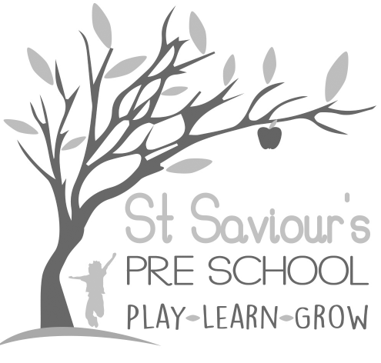
9.0 EQUAL OPPORTUNITIES

9.1 VALUING DIVERSITY AND PROMOTING EQUALITY

Written by: Claire Toms and Tina Alder Date: 1.09.22 – reviewed 31.8.25

Policy statement
St Saviour’s Pre-school and Nursery will ensure that our service is fully inclusive in meeting the needs of all children. We recognise that children and their families come from diverse backgrounds. All families have needs and values that arise from their individual, social, economic, ethnic, cultural, or religious backgrounds and situations.
Children grow up in diverse family structures, including two-parent and one-parent families; some children have two parents of the same sex. Some children have close links with extended families such as grandparents, aunts, uncles, and cousins; while others may live with foster carers, special guardians or in other family arrangements. Some children have needs that arise from a disability or may have parents that are affected by disability. Others may experience social exclusion or severe hardship, or face discrimination and prejudice because of their ethnicity, the languages they speak, their religious or belief background, their gender, or their impairment.
We understand that these factors affect children’s well-being, mental health and learning outcomes. We are committed to anti-discriminatory practice, to promoting equality of opportunity, and to valuing diversity and inclusion for all children and families, in line with the EYFS 2025 Safeguarding and Welfare Requirements and HCC Equalities Policy.

Procedures

Admissions
Our setting is open and accessible to all members of the community.
- We provide information in clear, concise language, whether in spoken, written or digital form.
- We base our Admissions Policy on a fair system and in line with Hertfordshire County Council admissions guidance.
- We ensure that all parents are made aware of our Valuing Diversity and Promoting Equality Policy.
- We do not discriminate against a child or their family, or prevent entry to our setting, on the basis of a protected characteristic as defined by the Equality Act 2010.
- We do not discriminate against a child with a disability or refuse a child entry to our setting for reasons relating to their disability.
- We make reasonable adjustments, in line with the Equality Act 2010 (SEND Code of Practice and EYFS 2025), to ensure that disabled children can participate successfully.
- Where possible, we support parents/carers with translation, accessible information formats, or signposting to HCC services.

Allocation of Places
- Our waiting list is arranged in order of receipt of a completed registration form.
- Nursery places (maximum 16) will be allocated according to the following criteria if oversubscribed:
  - Child currently attends St Saviour’s Pre-school.
  - A sibling has attended St Saviour’s Pre-school.
  - Date of receipt of registration form.
- All existing pre-school children will receive Nursery application forms on the same day.
- We keep a place vacant where possible to accommodate emergency or vulnerable admissions, in line with HCC guidance.
- We endeavour to welcome families from all ethnic, religious, and social groups, with and without disabilities.
- We monitor admissions data to ensure that no accidental discrimination takes place.

Employment
- Applicants are judged against explicit and fair criteria.
- All job descriptions include a commitment to equality and diversity.
- We monitor our application process to ensure it is fair and accessible.
- Recruitment procedures comply with the EYFS 2025 safer recruitment requirements.

Training
- Staff and volunteers are supported to develop inclusive practice and cultural competence, enabling all children to flourish.
- Staff receive training in SEND, EAL, anti-racism, unconscious bias, and inclusive teaching approaches in line with HCC recommendations.
- We ensure staff are confident and fully trained in administering relevant medicines and care procedures when required.
- Practices are regularly reviewed to ensure we are fully implementing this policy.

Curriculum
Our curriculum encourages children to develop positive attitudes about themselves and about others who are different from them.
We do this by:
- Making children feel valued and respected.
- Ensuring equality of access to learning.
- Making reasonable adjustments to the environment and resources to support children with a wide range of learning, physical and sensory needs.
- Providing differentiated learning opportunities to meet children’s individual needs, including those with SEND and EAL.
- Reflecting the widest possible range of communities in our resources.
- Avoiding stereotypes or derogatory images.
- Celebrating local, cultural and religious festivals inclusively.
- Embedding British Values (mutual respect, tolerance, democracy, rule of law, individual liberty) into our provision in line with EYFS 2025.
- Teaching children that discriminatory behaviour and remarks are unacceptable.
- Supporting children to maintain and develop their home languages alongside English.

Valuing Diversity
Children learn from an early age to value diversity in others and make a positive contribution to society.
We achieve this by:
- Valuing each child as an individual, recognising and respecting differences.
- Making connections between home, nursery, and the wider community.
- Encouraging families to share stories, experiences and cultural traditions.
- Working closely with parents to plan support where additional needs are identified.
- Encouraging equal involvement from mothers, fathers and carers.
- Promoting personalised learning and care so all children get the best possible start.
- Supporting inclusion for families who speak languages other than English.

Food
- We work with parents to meet dietary requirements arising from medical, religious or cultural needs.
- We encourage children to respect differences in food and mealtime routines.
- In line with EYFS 2025, we follow updated guidance on healthy eating, reducing sugar, and limiting the use of treats.

Monitoring and Reviewing
- Policies and procedures are monitored and reviewed annually.
- Equality and diversity objectives are evaluated in line with EYFS 2025 and HCC inclusion guidance.
- A complaints procedure and summary record is available for parents.
- Feedback from parents, staff and children informs updates to this policy.

